**Text Clssification**

We are going to classify the data based on text . and for that we are going to use unclassify data and check whether the tale is animal tale or tale of magic.

**Steps for text classification**

1. Take a Corpus and take grimTale.selected and to the corpusViewer.
2. In CorpusViewer take 10 ATU fields to provide data
3. 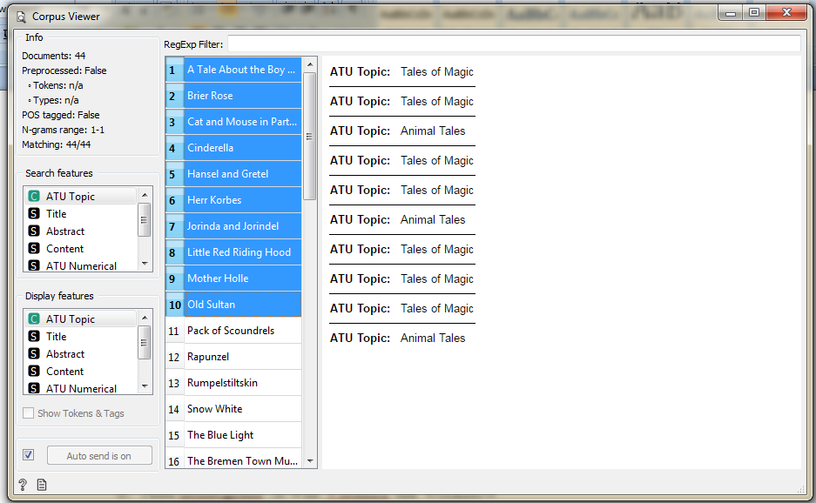
4. And to this add preprocess text for processing the data
5. And connect this to BagOfWords.
6. Take Logistic Regression to bag of words .it construct the model. 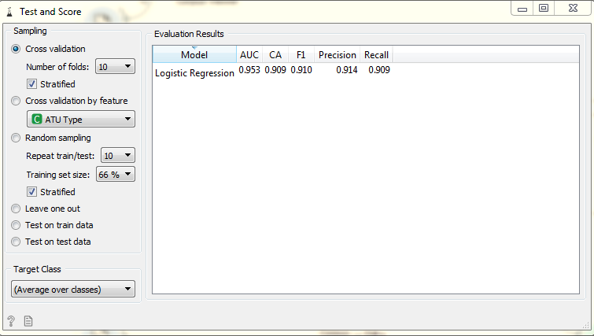
7. Add nomogram .it will Visulize the workflow 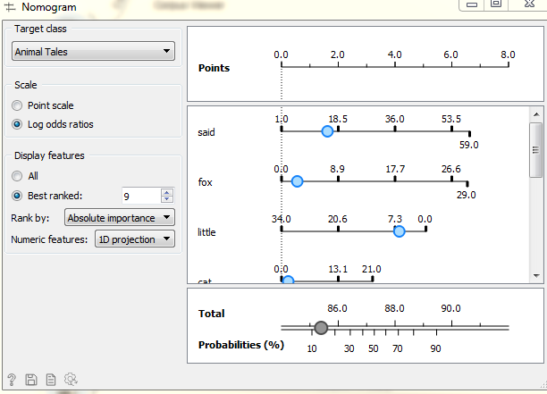
8. Add Test and Score it will cross validate the workflow 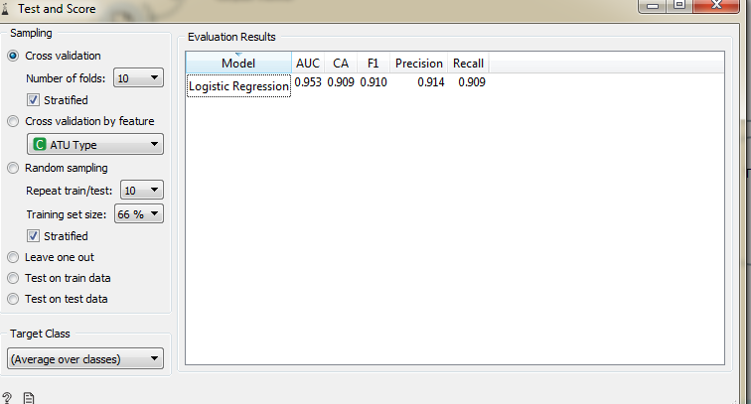
9. and to check our workflow whther it is right or wrong we take another corpus whom we alredy know the classification for that we use Andersen.tab and connect it to prediction 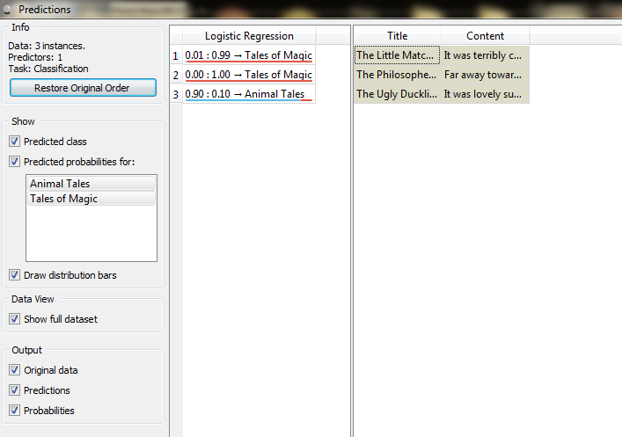
10. and finally our workflow looks like this 